Ubuntu has already been installed.

# Lab 1

**Exercise 1:**

**Exercise 2:**

Notes: -a -l -A are useful options.

**Exercise 4:**

Notes: you have to be outside of the directory in order to remove said directory.

**Exercise 5:**

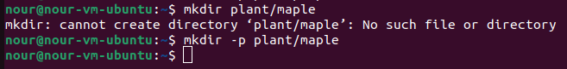

Notes: -p used in this case will remove both the parent and child folders.

**Exercise 6:**

**Exercise 7:**

**Exercise 8:**

Notes: 0 in this case, “total 0” means 0 bytes.

**Exercise 9:**

**Exercise 10**:

 

Notes: the command succeeded.